GREEN NATIONAL MODEL HIGH SCHOOL ADILPUR
CLASS: KG _{ANNUAL EXAMINATION 2025-26} _{SUBJECT: SINDH}
DATE: 10/03/2026 _{TIME ALLOWED 3 HOURS} MAX MARKS:100

SEAT NO: _______________ SIGNATURE: __________________

سوال 1 : ا کان ي تائين لکو.
جواب: _________________________________________________________________________________________________________________

________________________________________________________________________________________________________________

________________________________________________________________________________________________________________

________________________________________________________________________________________________________________

________________________________________________________________________________________________________________

________________________________________________________________________________________________________________

________________________________________________________________________________________________________________

________________________________________________________________________________________________________________
سوال 2 : ٽن نقطن وارا اکر لکو.
جواب :

_________________________________________________________________________________________________________________

__________________________________________________________________________________________________________________
سوال 3: چئن نقطن وارا اکر لکو:

جواب : ______________________________________________________________________________________________________________________

سوال 4 : هڪ جهڙا اکر ملايو.
جواب : س ض
ي ر
ع ق
ض ص
ر ي
ق ع
ص س

سوال 5 : هيٺين اکرن کي پيش ڏيو.

جواب : ا ب ج جھ د س ل م ء ي.

سوال 6 : هيٺين اکرن کي زير ڏيو.

جواب : ا ب ج جھ د س ل م ء ي.

سوال 7 : هيٺيان اکر مڪمل ڪريو.

جواب : ا _______ ٻ ___________ ت ___________ ٽ __________ ث _____________ ج ______________


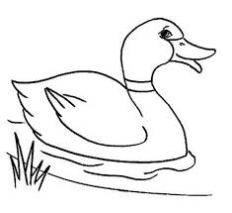


_______________ ________________ __________________

پورو ٿيو

